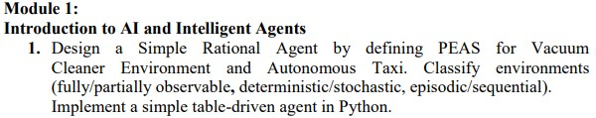
Code:
class TableDrivenVacuumAgent: def __init__(self):
# The percept history of the agent self.percept_history = []

# Look-up table: Maps a sequence of percepts to a specific action
# Percept format: (Location, Status) self.table = {
# Time step 1: Single percept sequences
((('A', 'Clean'),),): 'Right',
((('A', 'Dirty'),),): 'Suck', ((('B', 'Clean'),),): 'Left', ((('B', 'Dirty'),),): 'Suck',

# Time step 2: Two percept sequences (examples of history)
((('A', 'Clean'),), (('B', 'Dirty'),)): 'Suck',
((('A', 'Clean'),), (('B', 'Clean'),)): 'Right', # Patrolling
((('A', 'Dirty'),), (('A', 'Clean'),)): 'Right', # Sucked, now move ((('B', 'Dirty'),), (('B', 'Clean'),)): 'Left', # Sucked, now move

# Time step 3: Three percept sequences
((('A', 'Dirty'),), (('A', 'Clean'),), (('B', 'Dirty'),)): 'Suck', ((('A', 'Dirty'),), (('A', 'Clean'),), (('B', 'Clean'),)): 'Left',
}

def act(self, current_percept):
"""Appends current percept to history and looks up the next action.""" self.percept_history.append(current_percept)

# Convert history list to a tuple of tuples so it can be used as a dictionary key history_key = tuple(self.percept_history)

# Look up action in table; default to 'Right' if sequence isn't explicitly mapped action = self.table.get(history_key, 'Right') return action

# --- Simulation / Environment Loop --- if __name__ == "__main__":
agent = TableDrivenVacuumAgent()

# Simulating a sequence of steps in the environment # Step 1: Agent starts in Room A, which is Dirty percept_1 = ('A', 'Dirty') action_1 = agent.act(percept_1) print(f"Percept: {percept_1} -> Action: {action_1}")

# Step 2: Agent sucked the dirt, so Room A is now Clean percept_2 = ('A', 'Clean') action_2 = agent.act(percept_2) print(f"Percept: {percept_2} -> Action: {action_2}")

# Step 3: Agent moved Right and finds Room B is Dirty percept_3 = ('B', 'Dirty') action_3 = agent.act(percept_3) print(f"Percept: {percept_3} -> Action: {action_3}")

Output:
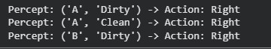

Problem Solving by Searching (Uninformed Search)
Code:
from collections import deque

class EightPuzzleBFS: def __init__(self, start_state, goal_state):
self.start_state = tuple(start_state) self.goal_state = tuple(goal_state)

# Valid moves mapped to index shifts in a 1D array representing a 3x3 grid
# Format: (index_delta, direction_name) self.moves = {
'Up': (-3, 'Up'),
'Down': (3, 'Down'),
'Left': (-1, 'Left'),
'Right': (1, 'Right')
}

def get_neighbors(self, state):
"""Generates all valid next states from the current state.""" neighbors = [] zero_idx = state.index(0) # Find the empty tile

# Determine 2D row and column from 1D index row, col = zero_idx // 3, zero_idx % 3

for move_name, (delta, direction) in self.moves.items():
new_idx = zero_idx + delta

# Boundary checks to ensure the move stays on the 3x3 board if direction == 'Up' and row == 0: continue if direction == 'Down' and row == 2: continue if direction == 'Left' and col == 0: continue if direction == 'Right' and col == 2: continue

# Swap the 0 with the target tile to create the new state state_list = list(state) state_list[zero_idx], state_list[new_idx] = state_list[new_idx], state_list[zero_idx] neighbors.append((tuple(state_list), move_name))

return neighbors

def solve(self):
"""Finds the shortest path from start_state to goal_state using BFS.""" if self.start_state == self.goal_state:
return []

# Queue stores: (current_state, path_of_moves_taken) queue = deque([(self.start_state, [])])

# Set to track visited states and prevent infinite loops visited = {self.start_state}

while queue:
current_state, path = queue.popleft()

# Explore all legal moves from the current configuration for next_state, action in self.get_neighbors(current_state): if next_state == self.goal_state:
return path + [action]

if next_state not in visited: visited.add(next_state) queue.append((next_state, path + [action]))

return None # Return None if no solution exists

def print_board(state):
"""Helper function to print the 3x3 board cleanly.""" for i in range(0, 9, 3):
print(f" {state[i]} {state[i+1]} {state[i+2]} ") print("-" * 11)

# --- Execution Example --- if __name__ == "__main__":
# 0 represents the empty space
# Simple configuration solvable in a few steps initial_configuration = (1, 2, 3,
4, 0, 5,
7, 8, 6)

goal_configuration = (1, 2, 3,
4, 5, 6,
7, 8, 0)

print("Initial State:")
print_board(initial_configuration)

solver = EightPuzzleBFS(initial_configuration, goal_configuration) solution = solver.solve()

if solution is not None:
print(f"Success! Shortest path found in {len(solution)} moves.") print(f"Sequence of moves: {solution}") else:
print("This configuration is unsolvable.") Output:
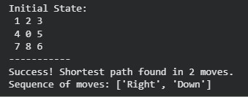

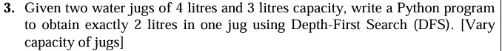

Code:
# Configure capacities and target dynamically
J1_CAP = 4 # Capacity of Jug 1
J2_CAP = 3 # Capacity of Jug 2
TARGET = 2 # Desired target volume in either jug

def get_next_states(state):
"""Generates all legal next steps from the current configuration.""" j1, j2 = state moves = []

# 1. Fill a jug completely moves.append((J1_CAP, j2)) # Fill Jug 1 moves.append((j1, J2_CAP)) # Fill Jug 2

# 2. Empty a jug completely moves.append((0, j2)) # Empty Jug 1 moves.append((j1, 0)) # Empty Jug 2

# 3. Pour from Jug 1 to Jug 2 pour_to_j2 = min(j1, J2_CAP - j2) moves.append((j1 - pour_to_j2, j2 + pour_to_j2))

# 4. Pour from Jug 2 to Jug 1 pour_to_j1 = min(j2, J1_CAP - j1) moves.append((j1 + pour_to_j1, j2 - pour_to_j1))

# Clean up duplicate or unchanged moves return list(set(moves))

def solve_water_jug_dfs():
# Stack stores tuples of: (current_state, path_taken) # Start with both jugs completely empty: (0, 0) stack = [((0, 0), [(0, 0)])] visited = {(0, 0)}

while stack:
(j1, j2), path = stack.pop() # Pop the latest element (LIFO behavior)

# Check if either jug has reached the target quantity if j1 == TARGET or j2 == TARGET: return path

for next_state in get_next_states((j1, j2)):
if next_state not in visited: visited.add(next_state)
# Append to stack to dive deeper down this new branch stack.append((next_state, path + [next_state]))

return None # No solution possible

# Execute and print path solution = solve_water_jug_dfs()

if solution:
print(f"Solution found using DFS ({len(solution)-1} steps):") for step, (j1, j2) in enumerate(solution):
print(f"Step {step}: Jug1 = {j1}L, Jug2 = {j2}L") else:
print(f"It is impossible to get exactly {TARGET}L with these jugs.")

Output:

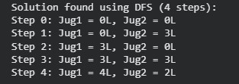

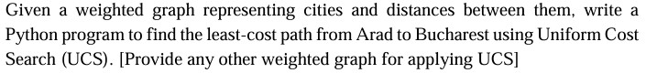

Code:
#citydistanceprogram import heapq

# 1. Define the weighted graph representing Romanian cities and distances
# Graph is represented as an adjacency list: { City: [(Neighbor, Cost), ...] }
# Alternate testing graph
ROMANIA_MAP = {
"Arad": [("Zerind", 75), ("Sibiu", 140), ("Timisoara", 118)],
"Zerind": [("Arad", 75), ("Oradea", 71)],
"Oradea": [("Zerind", 71), ("Sibiu", 151)],
"Timisoara": [("Arad", 118), ("Lugoj", 111)],
"Lugoj": [("Timisoara", 111), ("Mehadia", 70)],
"Mehadia": [("Lugoj", 70), ("Drobeta", 75)],
"Drobeta": [("Mehadia", 75), ("Craiova", 120)],
"Craiova": [("Drobeta", 120), ("Rimnicu Vilcea", 146), ("Pitesti", 138)],
"Sibiu": [("Arad", 140), ("Oradea", 151), ("Fagaras", 99), ("Rimnicu Vilcea", 80)],
"Rimnicu Vilcea": [("Sibiu", 80), ("Craiova", 146), ("Pitesti", 97)],
"Fagaras": [("Sibiu", 99), ("Bucharest", 211)],
"Pitesti": [("Rimnicu Vilcea", 97), ("Craiova", 138), ("Bucharest", 101)], "Bucharest": [("Fagaras", 211), ("Pitesti", 101)],
}
# 2. Uniform Cost Search Implementation def uniform_cost_search(graph, start, goal):
# Priority Queue stores tuples of: (cumulative_cost, current_node, path_taken) priority_queue = [(0, start, [start])]

# Keep track of visited nodes to avoid processing longer paths to the same city visited = set()

while priority_queue:
# Pull out the entry with the absolute lowest cumulative cost cost, current_node, path = heapq.heappop(priority_queue)

# The first time we pop the goal node, it is guaranteed to be the least-cost path if current_node == goal:
return path, cost

if current_node in visited: continue visited.add(current_node)

# Explore neighbors for neighbor, edge_cost in graph.get(current_node, []):
if neighbor not in visited:
total_cost = cost + edge_cost heapq.heappush(priority_queue, (total_cost, neighbor, path + [neighbor]))

return None, float('inf')

# 3. Run the UCS search start_city = "Arad" goal_city = "Bucharest"
optimal_path, total_cost = uniform_cost_search(ROMANIA_MAP, start_city, goal_city) Output:
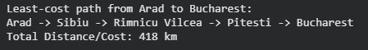

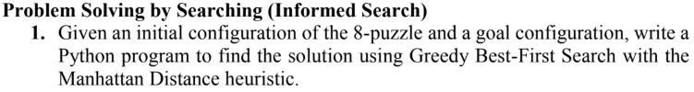
Code:
import heapq

# Define the goal state (0 represents the blank space)
GOAL_STATE = (1, 2, 3,
4, 5, 6,
7, 8, 0)

# Target positions (row, col) for each tile (0-8) to calculate Manhattan distance
GOAL_POSITIONS = {tile: (i // 3, i % 3) for i, tile in enumerate(GOAL_STATE)}

def get_manhattan_distance(state):
"""Calculates the sum of Manhattan distances of tiles from their goal positions.""" distance = 0 for i, tile in enumerate(state):
if tile != 0: # Skip the blank tile current_row, current_col = i // 3, i % 3 goal_row, goal_col = GOAL_POSITIONS[tile] distance += abs(current_row - goal_row) + abs(current_col - goal_col) return distance

def get_neighbors(state):
"""Generates next valid states by moving the blank tile (0).""" neighbors = [] blank_idx = state.index(0)
row, col = blank_idx // 3, blank_idx % 3

# Define possible moves: (row_offset, col_offset)
moves = [(-1, 0), (1, 0), (0, -1), (0, 1)] # Up, Down, Left, Right

for dr, dc in moves:
new_row, new_col = row + dr, col + dc if 0 <= new_row < 3 and 0 <= new_col < 3: new_blank_idx = new_row * 3 + new_col # Convert to list to swap tiles, then back to tuple new_state = list(state) new_state[blank_idx], new_state[new_blank_idx] = new_state[new_blank_idx], new_state[blank_idx] neighbors.append(tuple(new_state))

return neighbors

def greedy_best_first_search(start_state):
"""Solves the 8-puzzle using Greedy Best-First Search."""
# Priority queue stores tuples of: (heuristic_value, current_state, path_taken)
# heapq orders by the first element (heuristic_value) open_list = [] heapq.heappush(open_list, (get_manhattan_distance(start_state), start_state, [start_state]))

visited = set()
visited.add(start_state)

while open_list:
_, current_state, path = heapq.heappop(open_list)

# Check if goal is reached if current_state == GOAL_STATE: return path

# Explore neighbors for neighbor in get_neighbors(current_state): if neighbor not in visited: visited.add(neighbor) h_value = get_manhattan_distance(neighbor) heapq.heappush(open_list, (h_value, neighbor, path + [neighbor]))

return None # No solution found

def print_state(state):
"""Helper function to print the grid format nicely.""" for i in range(0, 9, 3): print(list(state[i:i+3])) print()

# --- Example Usage --- if __name__ == "__main__":
# 0 represents the empty space # An example initial state that is solvable initial_configuration = (1, 2, 3,
0, 4, 6,
7, 5, 8)

print("Initial State:")
print_state(initial_configuration)

solution_path = greedy_best_first_search(initial_configuration)

if solution_path:
print(f"Solution found in {len(solution_path) - 1} moves!\n") for step, state in enumerate(solution_path):
print(f"Step {step}:") print_state(state) else:
print("No solution could be found.") Output:

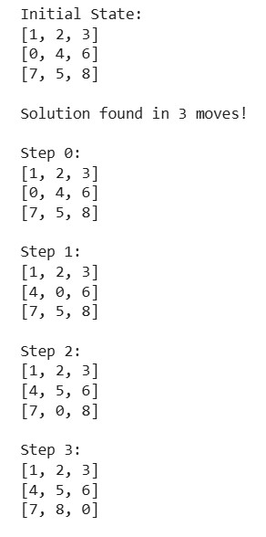

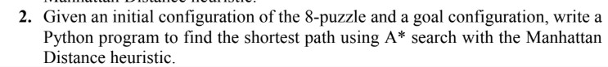

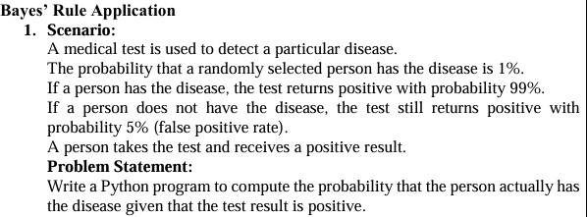

Code:
def calculate_disease_probability():
# Given data prob_disease = 0.01 # P(D) prob_no_disease = 0.99 # P(D')

true_positive_rate = 0.99 # P(T+|D) false_positive_rate = 0.05 # P(T+|D') # 1. Calculate the total probability of a positive test result P(T+) prob_positive_test = (true_positive_rate * prob_disease) + (false_positive_rate * prob_no_disease)

# 2. Apply Bayes' Theorem to calculate P(D|T+) prob_disease_given_positive = (true_positive_rate * prob_disease) / prob_positive_test

# Display the results print(f"Total probability of testing positive P(T+): {prob_positive_test:.4f}") print(f"Probability of actually having the disease given a positive test P(D|T+):
{prob_disease_given_positive:.4f}")
print(f"In percentage: {prob_disease_given_positive * 100:.2f}%")

if __name__ == "__main__":
calculate_disease_probability() Output:
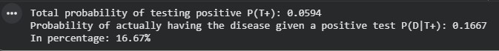

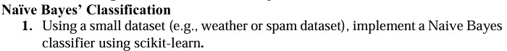

Code:
from sklearn.feature_extraction.text import CountVectorizer from sklearn.model_selection import train_test_split from sklearn.naive_bayes import MultinomialNB

# 1. Create a tiny dataset (Text, and Label: 1 for spam, 0 for ham) corpus = [
"Get rich quick! Click here now!", # Spam
"Hey, are we still meeting for lunch today?", # Ham
"Free cash prize! Claim your reward.", # Spam
"Can you send me the project report?", # Ham
"Urgent: Account suspended. Verification required.", # Spam
"Don't forget to buy milk on your way home.", # Ham
]
labels = [1, 0, 1, 0, 1, 0]

# 2. Convert text into numerical vectors (Bag of Words)
vectorizer = CountVectorizer() X = vectorizer.fit_transform(corpus) y = labels

# 3. Train the Naive Bayes model (MultinomialNB is great for text) model = MultinomialNB() model.fit(X, y)

# 4. Test the model with brand new emails test_emails = [
"Hey buddy, let's grab a coffee later.",
"CONGRATULATIONS! You won a free vacation! Click now",
]

# Convert test text using the same vectorizer X_test = vectorizer.transform(test_emails) predictions = model.predict(X_test)

# 5. Output the results for email, pred in zip(test_emails, predictions):
status = "SPAM 🚨" if pred == 1 else "HAM (Safe) ✅" print(f"Email: '{email}' --> Predicted as: {status}") Output:

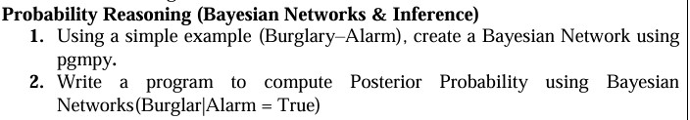

Code:
from pgmpy.factors.discrete import TabularCPD
from pgmpy.inference import VariableElimination
from pgmpy.models import DiscreteBayesianNetwork
# 1. Define the network structure
model = DiscreteBayesianNetwork([("Burglary", "Alarm"), ("Earthquake", "Alarm")])
# 2. Define Conditional Probability Distributions (CPDs)
# States are ordered as: [False, True]
cpd_b = TabularCPD(
variable="Burglary", variable_card=2, values=[[0.99], [0.01]] )
cpd_e = TabularCPD(
variable="Earthquake", variable_card=2, values=[[0.98], [0.02]]
)
# Column mapping for evidence [Burglary, Earthquake]:
# [False,False], [False,True], [True,False], [True,True] cpd_a = TabularCPD(
variable="Alarm",
variable_card=2,
values=[
[0.999, 0.06, 0.71, 0.05], # P(Alarm = False)
[0.001, 0.94, 0.29, 0.95], # P(Alarm = True)
],
evidence=["Burglary", "Earthquake"],
evidence_card=[2, 2],
)
# 3. Attach CPDs to the model
model.add_cpds(cpd_b, cpd_e, cpd_a)
# 4. Compute Posterior Probability: P(Burglary | Alarm = True)
inference = VariableElimination(model)
posterior = inference.query(variables=["Burglary"], evidence={"Alarm": 1})
print(posterior)

Output:
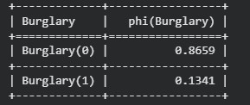

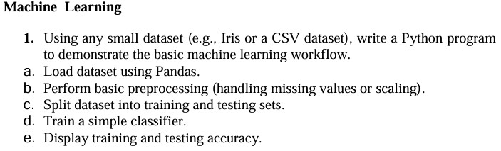

Code:
import pandas as pd from sklearn.datasets import load_iris from sklearn.metrics import accuracy_score from sklearn.model_selection import train_test_split from sklearn.preprocessing import StandardScaler from sklearn.svm import SVC

# =====================================================================
# a. Load dataset using Pandas
# =====================================================================
# We load the Iris dataset from sklearn and convert it into a Pandas DataFrame iris = load_iris() df = pd.DataFrame(data=iris.data, columns=iris.feature_names) df["target"] = iris.target

print("--- Step A: Dataset Loaded ---") print(df.head(), "\n")

# Separate features (X) and target label (y) X = df.drop(columns=["target"]) y = df["target"]

# =====================================================================
# b. Perform basic preprocessing
# =====================================================================
# 1. Handle missing values (if any) by filling them with the column mean X = X.fillna(X.mean())

# 2. Scale features so they have a mean of 0 and variance of 1 scaler = StandardScaler()
X_scaled = scaler.fit_transform(X)

print("--- Step B: Preprocessing Complete ---") print(f"Sample scaled feature row: {X_scaled[0]}\n")

# =====================================================================
# c. Split dataset into training and testing sets
# =====================================================================
# 80% of data goes to training, 20% goes to testing
X_train, X_test, y_train, y_test = train_test_split(
X_scaled, y, test_size=0.2, random_state=42
)

print("--- Step C: Dataset Split ---")
print(f"Training set size: {X_train.shape[0]} samples") print(f"Testing set size: {X_test.shape[0]} samples\n")

# =====================================================================
# d. Train a simple classifier
# =====================================================================
# Using a Support Vector Machine (SVM) classifier classifier = SVC(kernel="linear", random_state=42) classifier.fit(X_train, y_train)

print("--- Step D: Model Training Complete ---\n")

# =====================================================================
# e. Display training and testing accuracy
# =====================================================================
# Make predictions on both sets y_train_pred = classifier.predict(X_train) y_test_pred = classifier.predict(X_test)

# Calculate accuracy scores train_accuracy = accuracy_score(y_train, y_train_pred) test_accuracy = accuracy_score(y_test, y_test_pred)

print("--- Step E: Final Results ---") print(f"Training Accuracy: {train_accuracy * 100:.2f}%") print(f"Testing Accuracy: {test_accuracy * 100:.2f}%")

Output:
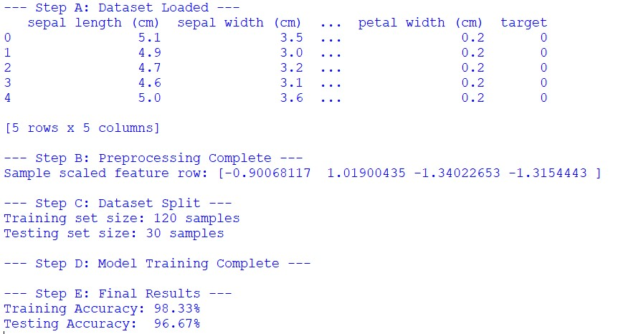

Code:
import pandas as pd from sklearn.datasets import load_diabetes from sklearn.linear_model import LinearRegression from sklearn.metrics import mean_squared_error, r2_score from sklearn.model_selection import train_test_split

# 1. Load the Diabetes regression dataset diabetes = load_diabetes()
X = pd.DataFrame(diabetes.data, columns=diabetes.feature_names) y = diabetes.target # Continuous target variable (disease progression)

# Let's use a single strong feature like 'bmi' for simple visualization/intuition X_bmi = X[["bmi"]]

# 2. Split into training and testing sets (80% train, 20% test)
X_train, X_test, y_train, y_test = train_test_split(
X_bmi, y, test_size=0.2, random_state=42
)

# 3. Initialize and train the Linear Regression model
model = LinearRegression() model.fit(X_train, y_train)

# 4. Make predictions on the test set y_pred = model.predict(X_test)

# 5. Evaluate the model's performance mse = mean_squared_error(y_test, y_pred) r2 = r2_score(y_test, y_pred)

print("--- Linear Regression Results ---") print(f"Model Coefficient (Slope): {model.coef_[0]:.2f}") print(f"Model Intercept: {model.intercept_:.2f}") print(f"Mean Squared Error (MSE): {mse:.2f}") print(f"R-squared Score (R²): {r2:.2f}")

Output:
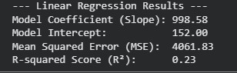

Code:
import matplotlib.pyplot as plt from sklearn.datasets import load_digits from sklearn.linear_model import LogisticRegression from sklearn.metrics import classification_report, confusion_matrix from sklearn.model_selection import train_test_split

# 1. Load the digits dataset (a smaller, built-in version of MNIST) digits = load_digits()
X = digits.data # Flattened pixel arrays (64 features per image) y = digits.target

# 2. Transform into a Binary Classification task: Is it a '5' or not?
# y_binary will be True (1) if the digit is 5, and False (0) for any other digit y_binary = y == 5

# 3. Split the data into training and testing sets
X_train, X_test, y_train, y_test = train_test_split(
X, y_binary, test_size=0.2, random_state=42
)
# 4. Train a Logistic Regression binary classifier model = LogisticRegression(max_iter=10000) model.fit(X_train, y_train)

# 5. Evaluate the model y_pred = model.predict(X_test)

print("--- Confusion Matrix ---") print(confusion_matrix(y_test, y_pred)) print("\n--- Classification Report ---")
print(classification_report(y_test, y_pred, target_names=["Not a 5", "Is a 5"]))

Output:
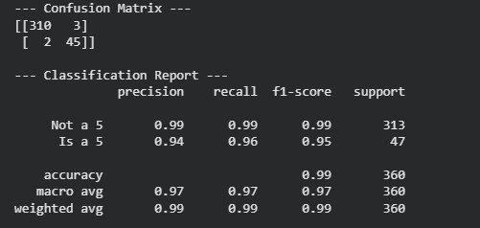

Code:
from sklearn.datasets import load_iris from sklearn.ensemble import RandomForestClassifier from sklearn.model_selection import KFold, cross_val_score

# 1. Load a sample dataset iris = load_iris()
X, y = iris.data, iris.target

# 2. Initialize the classification model
model = RandomForestClassifier(random_state=42)

# 3. Set up the K-Fold strategy (e.g., 5 folds)
# shuffle=True ensures the data is mixed before splitting kf = KFold(n_splits=5, shuffle=True, random_state=42)

# 4. Perform K-Fold Cross-Validation
# This automatically handles the splitting, training, and evaluating scores = cross_val_score(model, X, y, cv=kf, scoring="accuracy")

# 5. Display the results print("--- 5-Fold Cross-Validation Results ---") for fold_idx, score in enumerate(scores, 1):
print(f"Fold {fold_idx} Accuracy: {score * 100:.2f}%")

print("-" * 38)
print(f"Mean Accuracy: {scores.mean() * 100:.2f}%") print(f"Std Deviation: {scores.std() * 100:.2f}%")

Output:
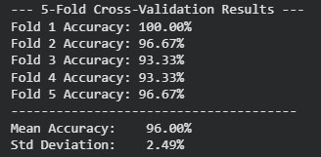

Code:
from sklearn.datasets import load_iris from sklearn.metrics import accuracy_score from sklearn.model_selection import train_test_split from sklearn.tree import DecisionTreeClassifier, export_text

# 1. Load the Iris dataset iris = load_iris()
X, y = iris.data, iris.target

# 2. Split into training and testing sets (80% train, 20% test)
X_train, X_test, y_train, y_test = train_test_split(
X, y, test_size=0.2, random_state=42
)
# 3. Initialize and train the Decision Tree Classifier
# We set max_depth to keep the tree simple and avoid overfitting model = DecisionTreeClassifier(max_depth=3, random_state=42) model.fit(X_train, y_train)

# 4. Evaluate the model y_pred = model.predict(X_test) accuracy = accuracy_score(y_test, y_pred) print(f"Testing Accuracy: {accuracy * 100:.2f}%\n")

# 5. Display the decision rules in text format print("--- Learned Decision Tree Rules ---")
tree_rules = export_text(model, feature_names=list(iris.feature_names)) print(tree_rules) Output:
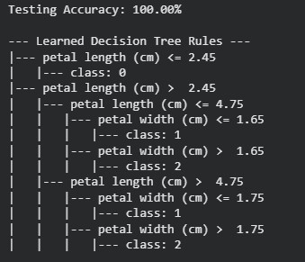

Code:
import pandas as pd from sklearn.datasets import load_diabetes from sklearn.metrics import mean_squared_error, r2_score from sklearn.model_selection import train_test_split from sklearn.tree import DecisionTreeRegressor, export_text

# 1. Load the regression dataset diabetes = load_diabetes()
X = pd.DataFrame(diabetes.data, columns=diabetes.feature_names) y = diabetes.target

# 2. Split into training and testing sets (80% train, 20% test)
X_train, X_test, y_train, y_test = train_test_split(
X, y, test_size=0.2, random_state=42
)

# 3. Initialize and train the Decision Tree Regressor
# max_depth keeps the tree compact and prevents severe overfitting regressor = DecisionTreeRegressor(max_depth=3, random_state=42) regressor.fit(X_train, y_train)

# 4. Make predictions and evaluate y_pred = regressor.predict(X_test) mse = mean_squared_error(y_test, y_pred) r2 = r2_score(y_test, y_pred)

print("--- Evaluation Metrics ---") print(f"Mean Squared Error (MSE): {mse:.2f}") print(f"R-squared Score (R²): {r2:.2f}\n")

# 5. Display a sample of the tree rules print("--- Learned Regression Rules (First few levels) ---") tree_rules = export_text(regressor, feature_names=list(diabetes.feature_names)) print(tree_rules)

Output:
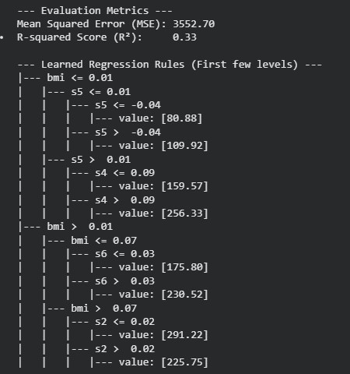

Code:
from sklearn.datasets import load_iris from sklearn.metrics import accuracy_score from sklearn.model_selection import train_test_split from sklearn.neighbors import KNeighborsClassifier from sklearn.preprocessing import StandardScaler

# 1. Load the Iris dataset iris = load_iris()
X, y = iris.data, iris.target

# 2. Split into training and testing sets (80% train, 20% test)
X_train, X_test, y_train, y_test = train_test_split(
X, y, test_size=0.2, random_state=42
)

# 3. Scale the features
# Crucial for k-NN because it relies on calculating geometric distances scaler = StandardScaler()
X_train_scaled = scaler.fit_transform(X_train)
X_test_scaled = scaler.transform(X_test)

# 4. Initialize and train the k-NN Classifier (using 3 neighbors) knn = KNeighborsClassifier(n_neighbors=3) knn.fit(X_train_scaled, y_train)

# 5. Make predictions and evaluate accuracy y_pred = knn.predict(X_test_scaled) accuracy = accuracy_score(y_test, y_pred)

print(f"k-NN Classifier Accuracy (k=3): {accuracy * 100:.2f}%")

Output:

Code:
from sklearn.datasets import load_iris from sklearn.linear_model import LogisticRegression from sklearn.metrics import classification_report from sklearn.model_selection import train_test_split from sklearn.preprocessing import StandardScaler

# 1. Load the Iris dataset (3 target classes: 0, 1, or 2) iris = load_iris()
X, y = iris.data, iris.target

# 2. Split into training and testing sets (80% train, 20% test)
X_train, X_test, y_train, y_test = train_test_split(
X, y, test_size=0.2, random_state=42
)

# 3. Scale features (Highly recommended for Logistic Regression convergence) scaler = StandardScaler()
X_train_scaled = scaler.fit_transform(X_train)
X_test_scaled = scaler.transform(X_test)

# 4. Train a Multiclass Logistic Regression model
# multi_class='ovr' trains a separate binary classifier for each class model = LogisticRegression(multi_class="ovr", random_state=42) model.fit(X_train_scaled, y_train)

# 5. Evaluate the model
y_pred = model.predict(X_test_scaled)

print("--- Multiclass Classification Report ---") print(classification_report(y_test, y_pred, target_names=iris.target_names))

Output:
